|  |
| --- |
| The Electronics Club IIT Indore  Sponsorship Brochure |
| The Electronics Club IIT Indore,  Simrol, Madhya Pradesh -452 020  Phone: +91 94418 01234  Email: [elecclub@iiti.ac.in](mailto:elecclub@iiti.ac.in)  Website: http://elecclub.iiti.ac.in |

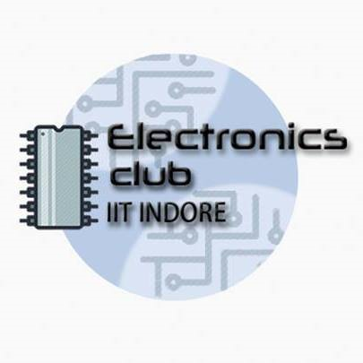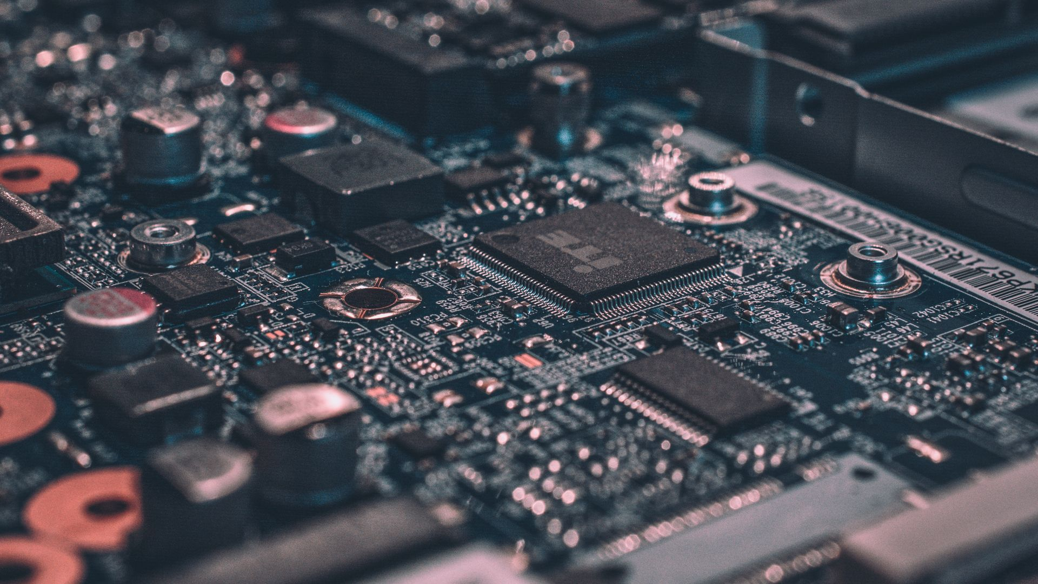



## Content Page No

## Who We Are? ................................. 3

## What We Do? ……………………………. 3

## Plans for the Academic Year 2018-19 ……………………………. 11

## Sponsorship Option !! ………….. 12

## Why Invest in Us? ………………….. 13

## Contact Us …………………………… 13

### **Who We Are?**

### The Electronics Club is an eminent student-run organization at IIT Indore which firmly believes that the most innovative and creative solutions arise from the diversity of thought. We have an interdisciplinary team of highly motivated and enthusiastic undergraduates from all corners of campus to connect, collaborate, and create.

### Image may contain: 15 people, people smiling, people standing and stripesThe Team

### **What We Do?**

We diligently work towards building a collaborative, resource-rich organisation which harbingers the innovations and assists the student community in designing, building, and testing Electronics. We also strive to inculcate more of the community into electronics by providing hand-on experience, workshops and hackathons.

##### A Glimpse of the Previous Academic Year 2017-18

1. 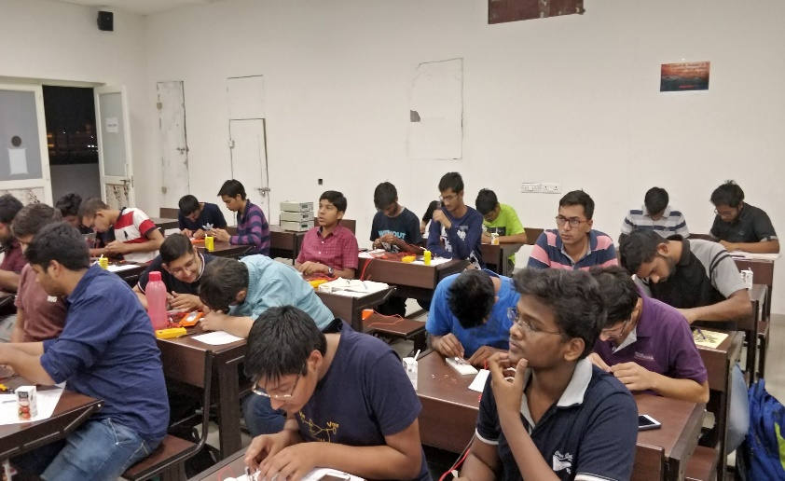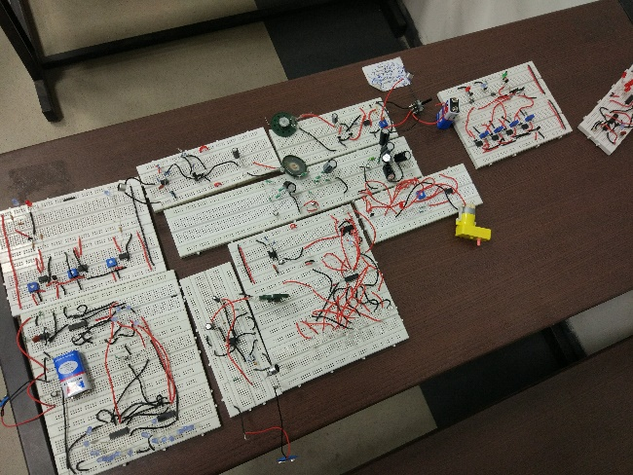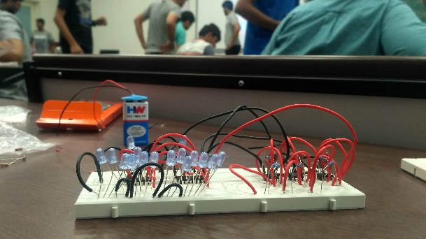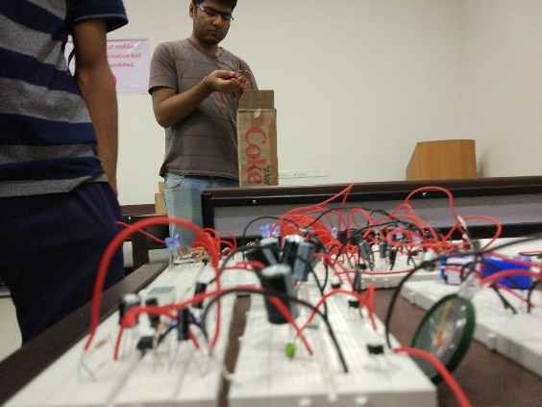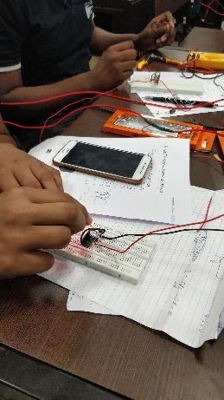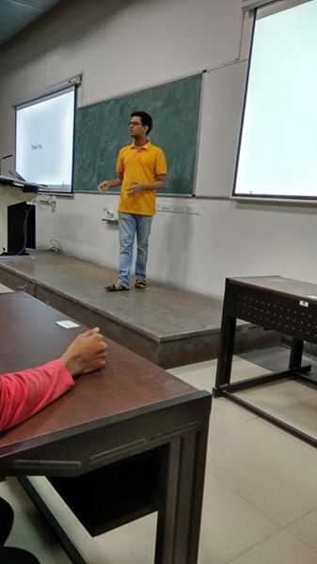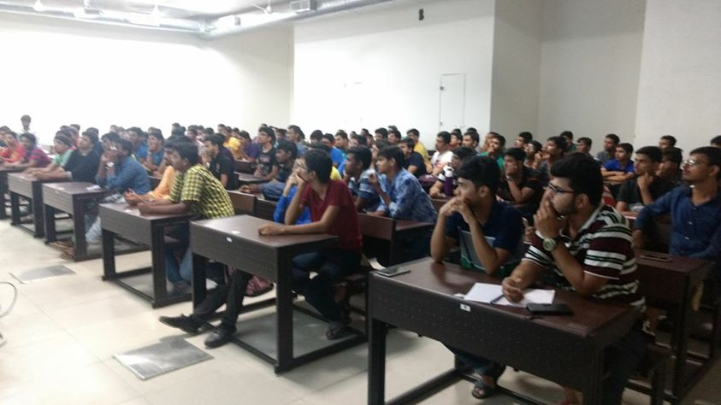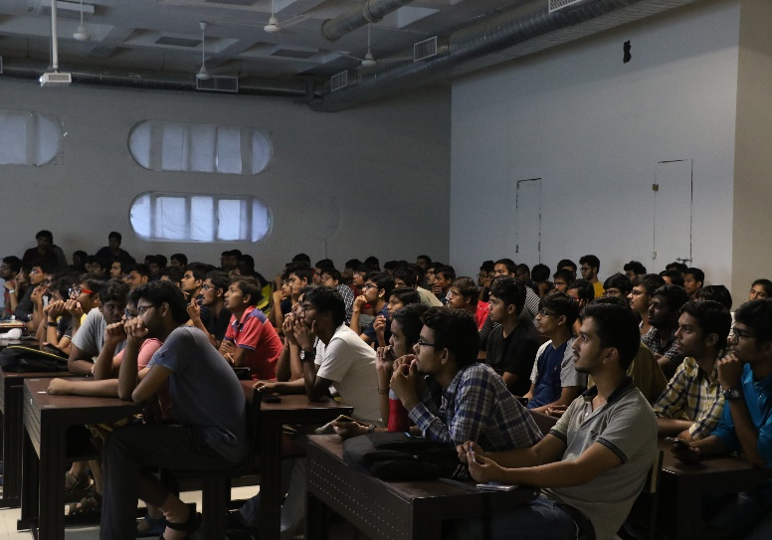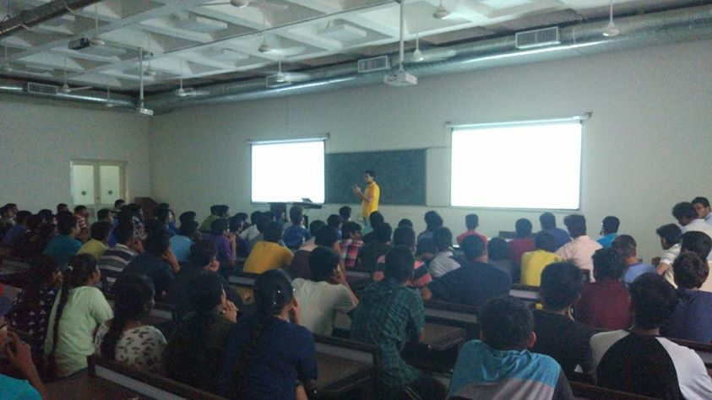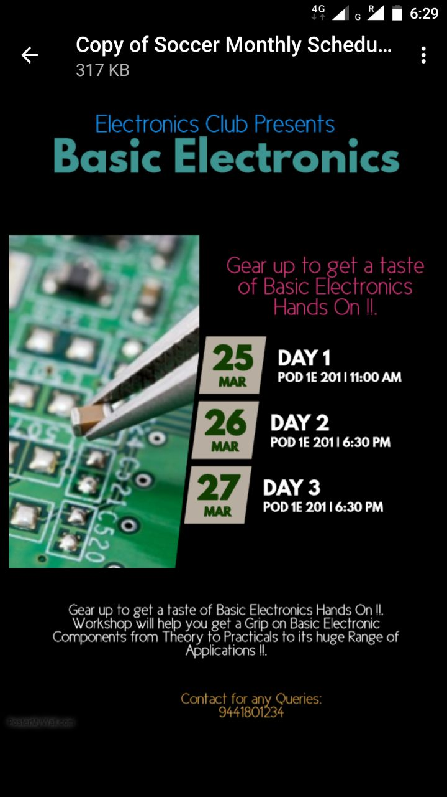Basic Electronics Workshop: An Introduction to Basic Electronics, Along with Hands on sessions, First Workshop of the year.
2. 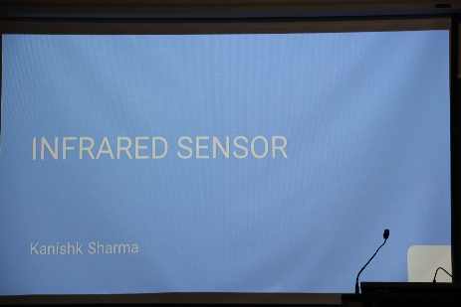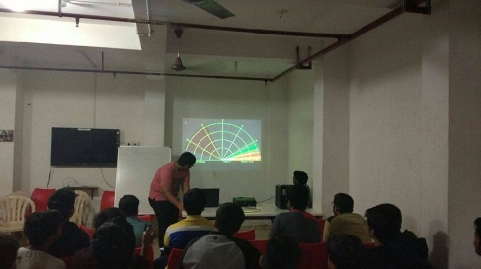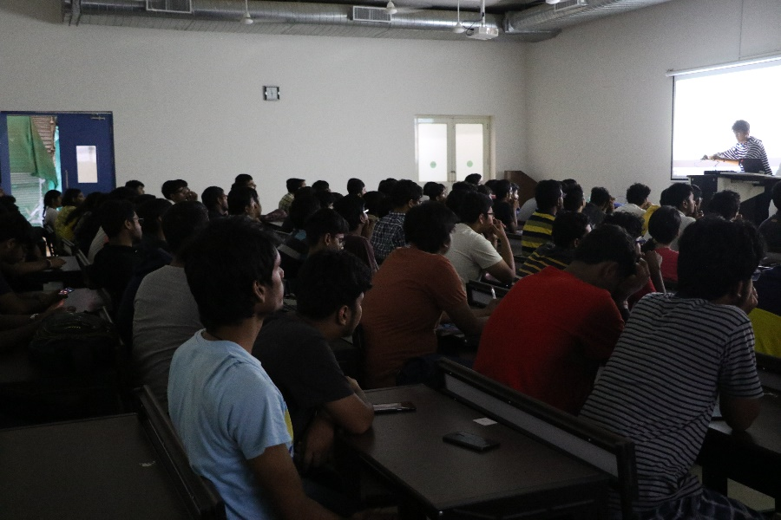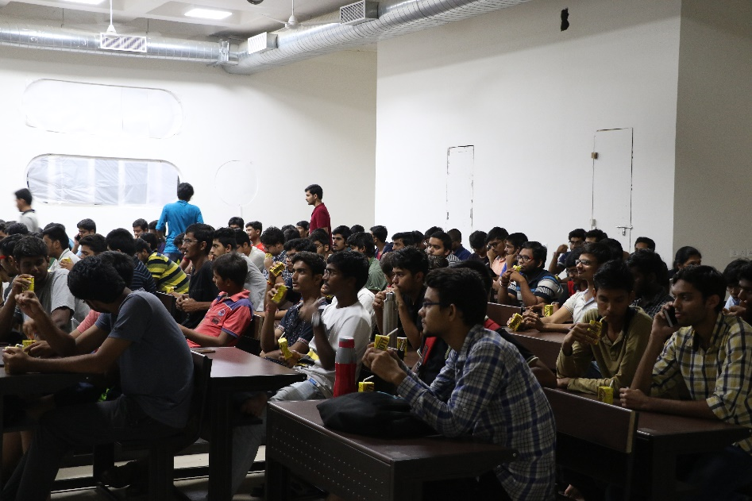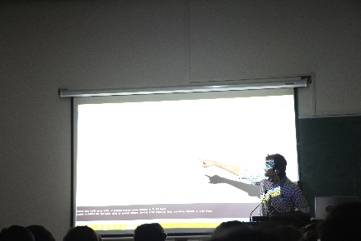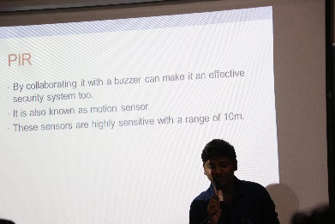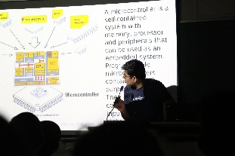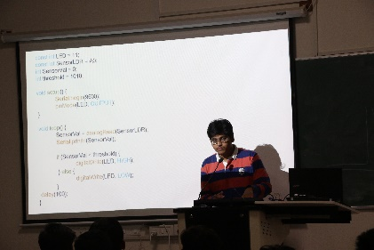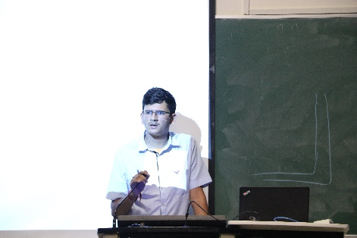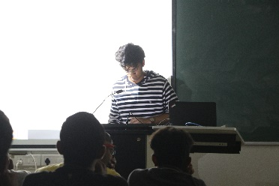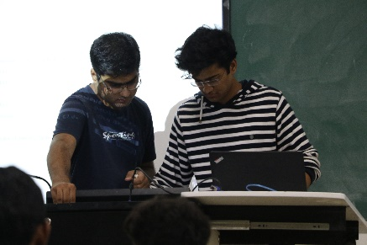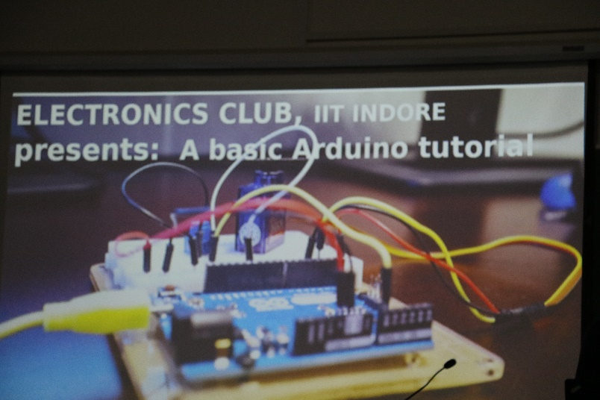Arduino Workshop: An Introduction to Arduino Microcontroller, followed by exhibition of Arduino & Sensors based Projects.

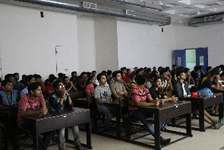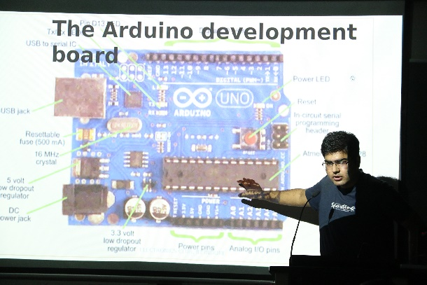

1. 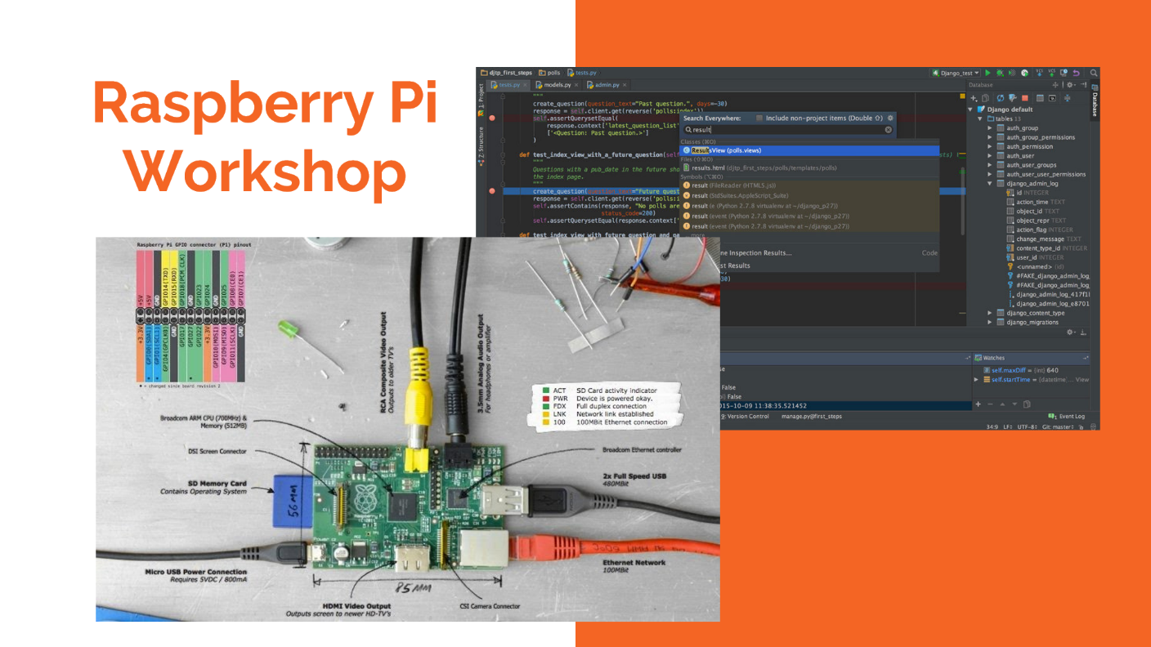Raspberry Pi Workshop: An Introduction to Raspberry Pi
2. 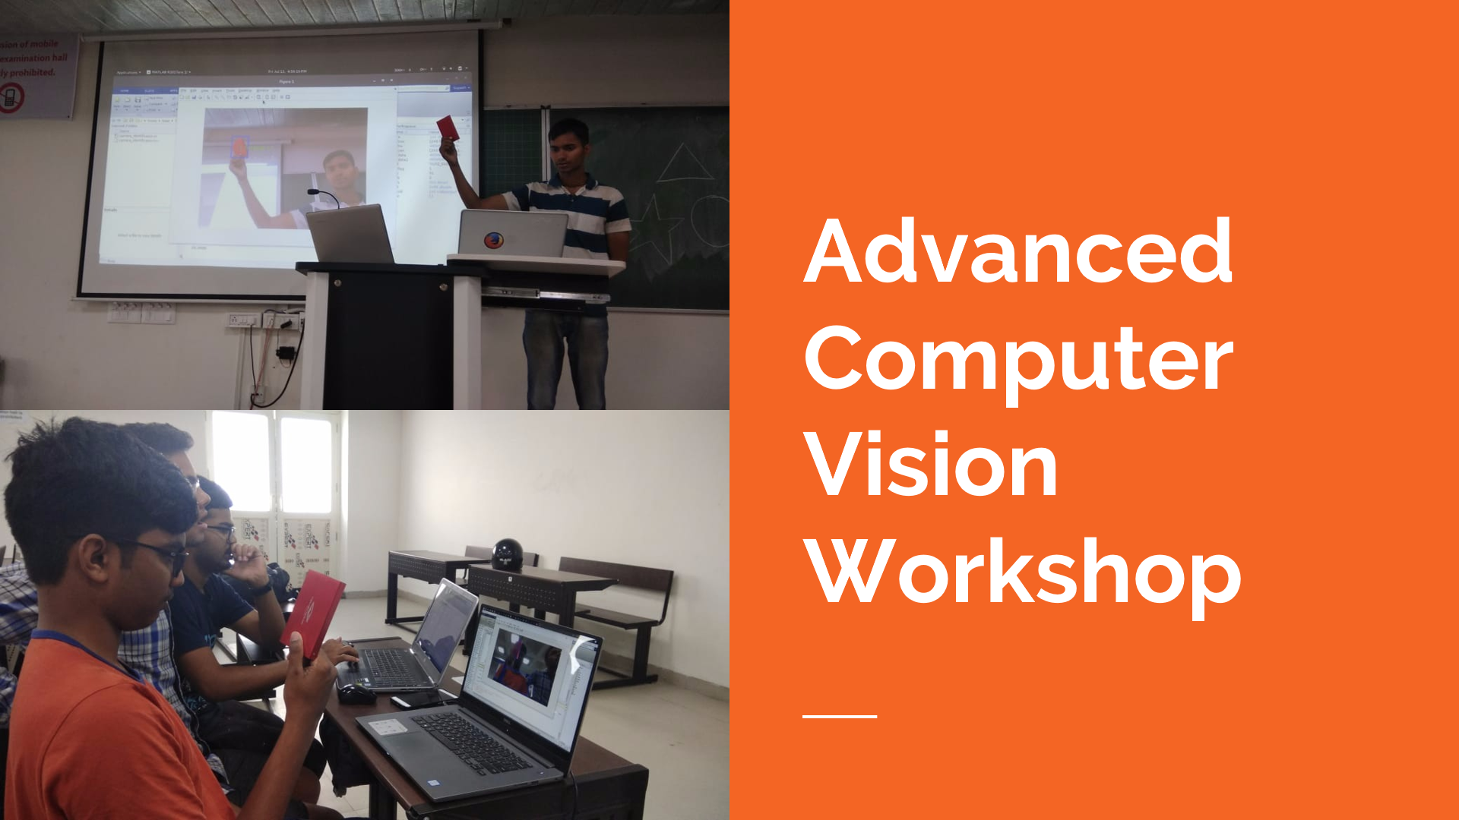Beginners to Advanced Computer Vision Workshop: Two weeks long Summer course on Computer Vision.
3. Projects and Competitions
   1. 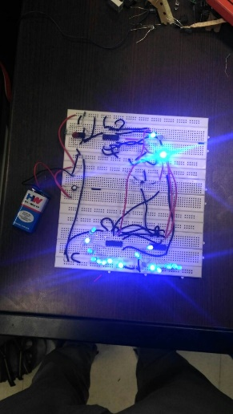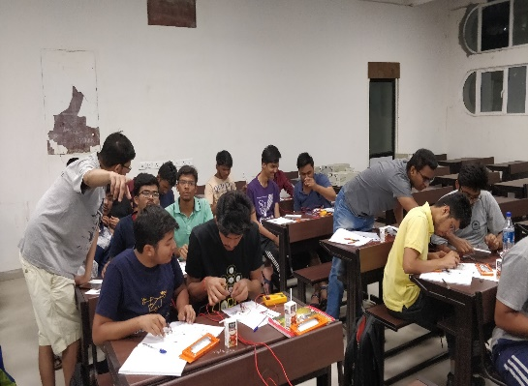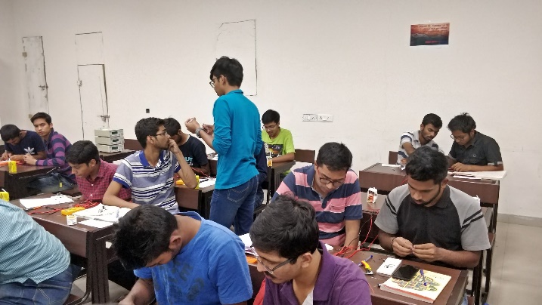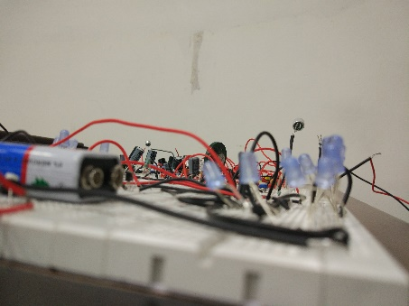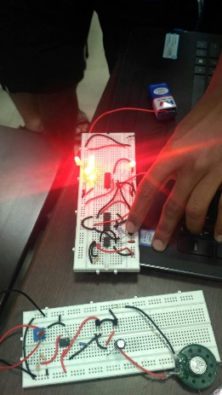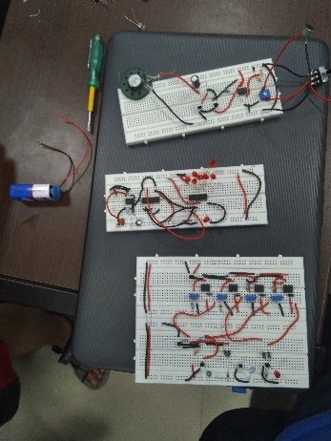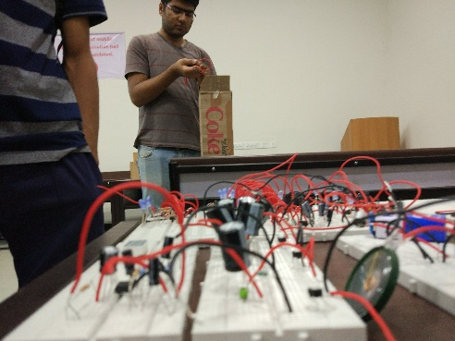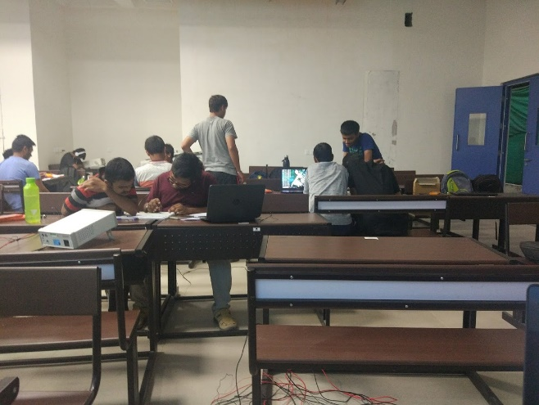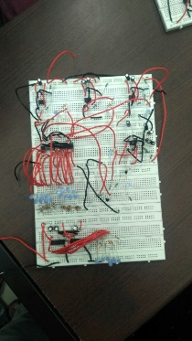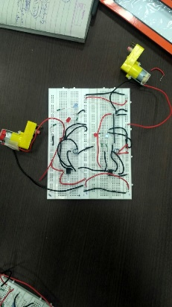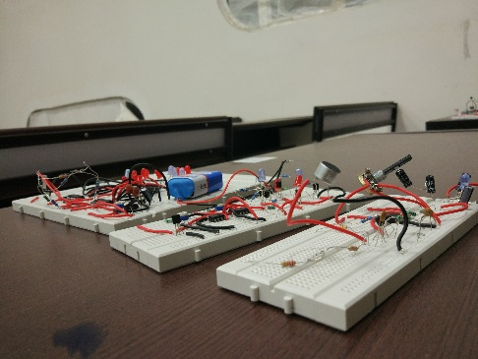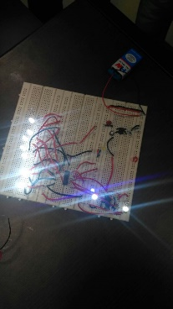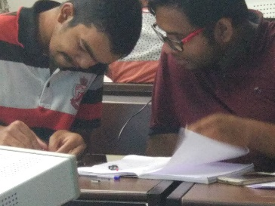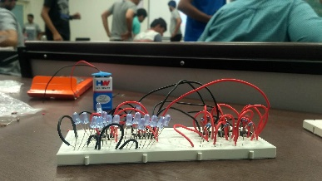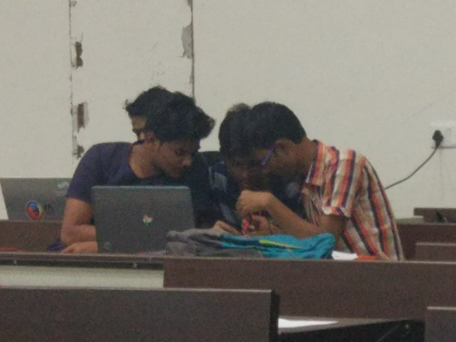Make-a-thon 2k18: One of a kind 24h long Electronics hackathon.
   2. 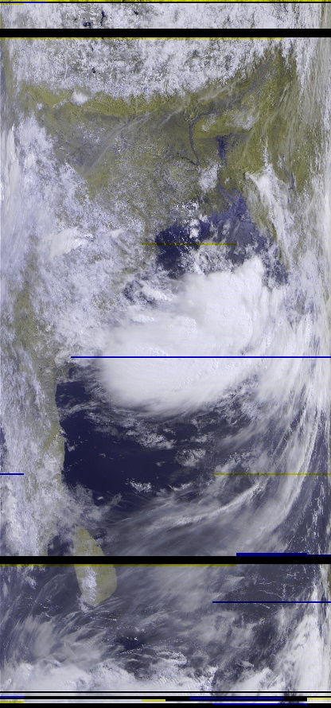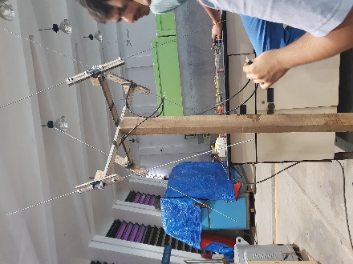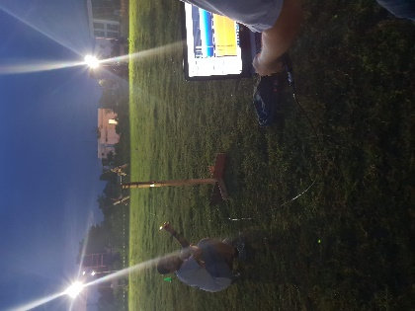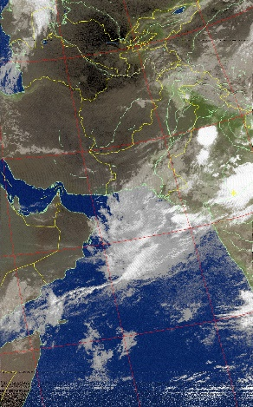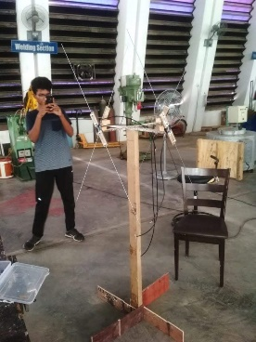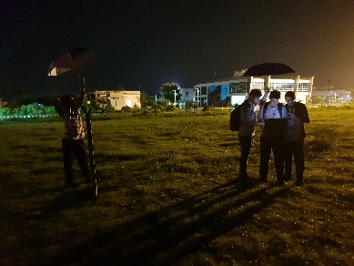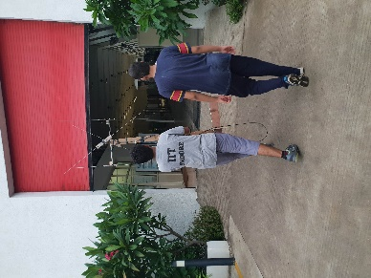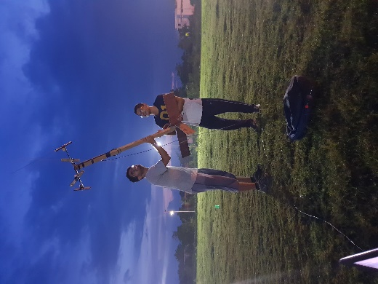Ground Station Project: Satellite Receiver Terminal @ 137Mhz.
   3. 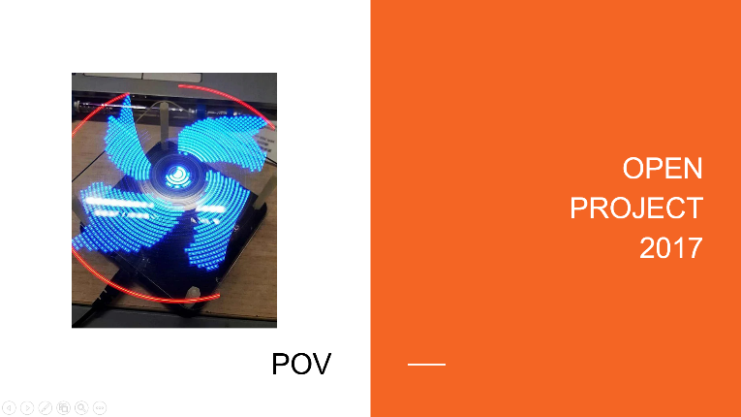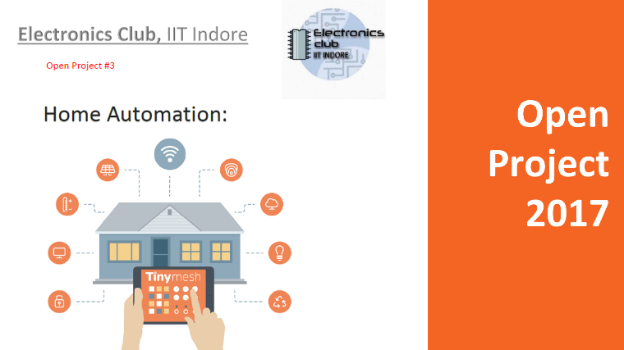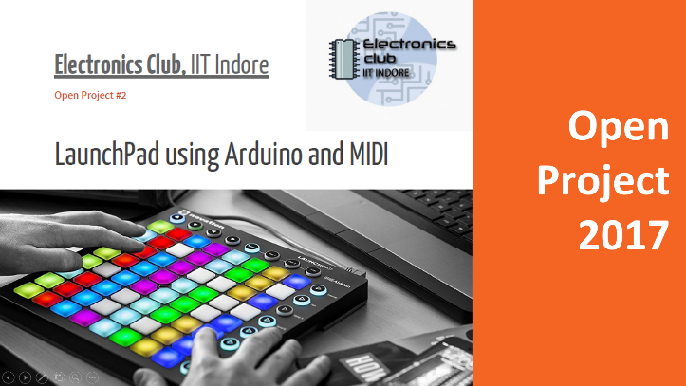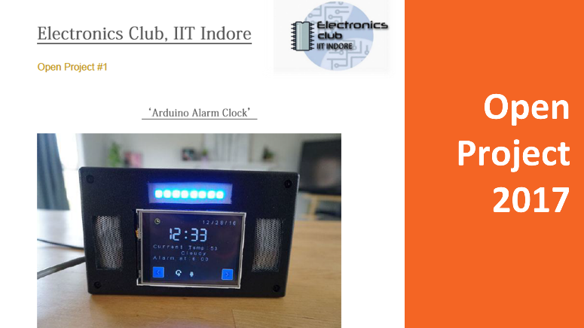Several Other Open Projects

#### PLans for the Academic Year 2018-19

* Electronics Lab Initiative: is a medium-term Investment Option (Duration ~1-3 Years), We appreciate Investment in the form of Electronic Components and/or Direct Monetary investment to setup a fully functional Student Lab, to provide a platform for students to experiment and innovate. The Electronics Lab is located at the heart of the Electrical Department in the Academic Building.
* Workshops: Event Date
  + Basic Electronics Workshop 2nd Week Sept 2018
  + Arduino Workshop 1st Week Oct 2018
  + Raspberry Pi Workshop 2nd Week Jan 2019
  + Advanced Electronics Workshop (new) 1st Week Feb 2019
* Projects and Competitions:
  + Make-a-thon 2k19 2nd Week Feb 2019
  + Open Projects Starting from Mid Oct 2018
* Ground Station Project -II: Extend the capabilities of the existing receiver to receive @1.7GHz, and enable Data Transmission Capability.

# Sponsorship Options !!

We Offer:

* 1. **Electronics Lab Initiative**:  
     Company Logo on
     1. The Electronics Club Website Home page.
     2. Electronics Lab Page (……..coming soon).
     3. Posters Inside the Lab + Space for Upto 4 product Advertisements (upto A3 size)

Tittle Sponsor for The Lab (Poster on the Entrance).

# Total Amount: ₹1,00,000/-*(or Equivalent in Components)* (~USD 1,400)

* 1. **Basic Electronics Workshop + Advance Electronics Workshop**Company Logo on
     1. The Electronics Club Website Event page.
     2. On the Event Posters.

Mention of the Company during the Workshop.

Tittle Sponsor for The Workshop(Mention of Company in all communication Emails)

Distribution of Company Merchandise(Stickers/Badges/Pamphlets if any)

# Total Amount: ₹40,000/- (~USD 550)

* 1. **Arduino Workshop + Raspberry Pi Workshop**Company Logo on
     1. The Electronics Club Website Event page.
     2. On the Event Posters.

Mention of the Company during the Workshop.

Tittle Sponsor for The Workshop(Mention of Company in all communication Emails)

Distribution of Company Merchandise(Stickers/Badges/Pamphlets if any)  
  
Total Amount: ₹30,000/- (~USD 450)

* 1. **Make-a-thon 2k19:**Company Logo on
     1. The Electronics Club Website Competition page.
     2. On the Event Posters.
     3. Additional Posters Inside the Competition Room + Space for Upto 8 product Advertisements (upto A3 size) during the 24h long Event.

Tittle Sponsor for Competition(Mention of Company in all communication Emails)

Distribution of Company Merchandise(Stickers/Badges/Pamphlets if any)

Total Amount: ₹35,000/- (~USD 500)

* 1. **Ground Station Project-II:**Company Logo on
     1. The Electronics Club Website Project page.
     2. Company Logo on the Antennas

Tittle Sponsor for Project(Mention of Company in all communication Emails)

Total Amount: ₹10,000/- (~USD 150)

**Interested in Sponsoring All the Club Activities ??**

Additional Benefits:

1. Company Logo on The Electronics Club, IIT Indore Annual T-shirt and/or Hoodie.
2. Exclusive Company Logos everywhere (+Larger Icon Size)

Total Amount: ₹2,00,000/- (~USD 2900)

## Why Invest in Us?

* We could help strengthen and drive your efforts to establish relations with IIT Indore (as muRata is an investor in Shirucafe at IIT Indore), Collaboration with The Electronics Club at IIT Indore would establish a powerful Image of the Company among the students, as well as with the faculty, And also emphasizes the Company’s dedication toward Electronics, which is also inline with the vision of the company to be an “***Innovator in Electronics***” and the “***World's Top Supplier of Electronics Components***”.
* We can Help Organize Workshops/Talks on Company Products/Services, On behalf of The Electronics Club.
* Be part of our future Social Outreach Projects (like the Sanitary Napkin Vending Machine).

Contact Us

Email ID: elecclub@iiti.ac.in

Facebook Page: <https://www.facebook.com/iitielectronicsclub/>

LinkedIn Page: <https://www.linkedin.com/company/elecclub-iit-indore/>

Official Website: <http://elecclub.iiti.ac.in/>

Address: The Electronics Club, IIT Indore, Simrol, Madhya Pradesh-452020

Additional Contact Details:   
 K Sreevatsank   
(President of The Electronics Club, IIT Indore)

Ph.No: +91 9441801234  
 +91 8919423139